Task 2 Generating design of other traditional database model CO1, K3
Aim: To create a traditional database using Hierarchical and Network models and convert/enhance it into a relational schema, identify inheritance relationships, perform constraints, and implement using SQL (DDL + DCL).
Question:
Creating Hierarchical /Network model of the database by enhancing the sound abstract data by performing following tasks using forms of inheritance:
- a Identify the specificity of each relationship, find and form surplus relations.
2. b Check is-a hierarchy/ has-a hierarchy and performs generalization and/or specialization relationship.
2. c Find the domain of the attribute and perform check constraint to the applicable.
2. d Rename the relations.
2. e Perform SQL Relations using DDL, DCL commands.

Sample output:
Revoke all from user1;
- f Using create, design Relational Hierarchical model and Relational Network Model ER diagrams.

1. Scenario for Database Modeling
Domain: University Management System
Entities:
- University
- Department
- Professor
- Course
- Student
Relationships:
- University has multiple Departments (1:M)
- Department offers many Courses (1:M)
- Professor teaches multiple Courses (M:N)
- Student enrolls in multiple Courses (M:N)

Specificity and Surplus Relationships
Specific Relations:
University → Department (1:M)
Department → Course (1:M)

Surplus (Derived) Relations:
- Teaches (Professor → Course)
- Enrollment (Student → Course)

2.b Inheritance Hierarchy and Relationships
- IS-A Hierarchy:
- Person
- Professor
- Student
- HAS-A Hierarchy:
- Department HAS-A HOD (Professor)
Generalization/Specialization:
- Person (person_id, name, contact)
- Professor (professor_id, designation)
- Student (student_id, batch)

2.c Domain and Constraints
Attribute | Domain / Constraint
age | INTEGER CHECK (age BETWEEN 18 AND 60)
email | VARCHAR(50) UNIQUE NOT NULL
course_code | VARCHAR(10) PRIMARY KEY
grade | CHAR CHECK (grade IN ('A','B','C','D','F'))

2.d Relation Renaming for Normalization
Old Name | New Name
Professor | Faculty
Department | Dept
Enrollment | Course_Registration
Teaches | Course_Assignment

2.c: Find domain of attribute + Check constraint
Attribute | Domain / Constraint
age | INTEGER CHECK (age BETWEEN 18 AND 60)
email | VARCHAR(50) UNIQUE NOT NULL
course_code | VARCHAR(10) PRIMARY KEY
grade | CHAR CHECK (grade IN (‘A’,’B’,’C’,’D’,’F’))

2.d: Rename the relations
For clarity and normalization:
Professor → Faculty
Department → Dept
Enrollment → Course_Registration
Teaches → Course_Assignment

2.e: SQL Implementation (DDL + DCL)

DDL – Schema Creation

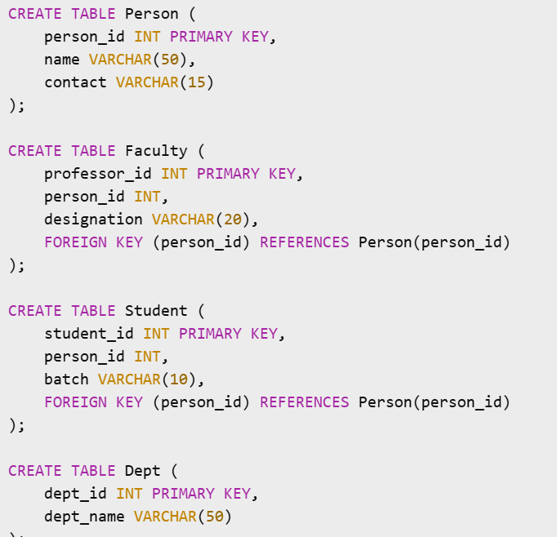

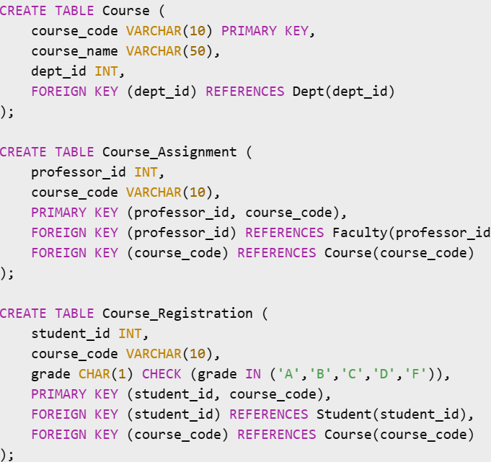

DCL – Permission Control
--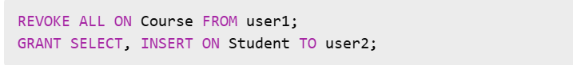

2.f: Create Hierarchical & Network Models in ER Diagram (Using Creately or Similar Tools)

Hierarchical Model
University
|
|---> Department
|
|---> Course
|
|---> Student

✅ Network Model
[Faculty] --- teaches ---> [Course] <--- enrolled by --- [Student]
↑ ↑
offered by belongs to
↓ ↓
[Department] ---------> [University]
Use diamond shapes for relationships and ellipses for attributes. Arrows represent cardinality.

